An NHS Dentist 4 all – Improving Dental Services across Lincolnshire
Social Media Messages
1st October 2022 – 31st March 2022

About this campaign
‘An NHS Dentist 4 all – Improving Dental Services across Lincolnshire’ is a campaign started by Healthwatch Lincolnshire in response to the number of poor experiences shared with us by residents of Lincolnshire of Dental Service. Over the past year, the frequency of these comments coming into us has rapidly increased. We hear from members of the public who are:
- Unable to find an NHS practice taking on new adult or child patients (despite ringing numerous practices, often miles away from where they live)
- Living in pain due to untreated dental problems. This is having a negative effect on both mental and physical health
- In need of dental treatment – however, all they are offered is private treatment which is not affordable for the majority. As a result of not being able to get treatment, their oral health has deteriorated further, meaning they now need more treatment
- Recently, we have heard of a number of practices handing back their NHS contract and turning completely private – this adds additional individuals to a pool of people trying to find NHS treatment
We have been hearing these problems since as far back as 2015, however, over the past year, the frequency of these comments has increased rapidly. During this time, we have raised both yours and our concerns about the decline in access to NHS Dentists in our county with NHS England Midlands Dental Commissioning Team, media, Healthwatch England and our local and regional dental networks.
Whilst we all recognise many of the problems with dental services in Lincolnshire, such as commissioning, workforce and geography. What we see is little to no improvement being actioned.
With this campaign we would like to raise awareness of the issues with NHS Dental Services in Lincolnshire at both a local and national level and encourage the public to share their experiences of services.

Social media messages
Use the following social media messages to support the campaign on your own channels. These are all tailored to different platforms.

Messages focused on encouraging people to come forward and share their experiences of NHS Dental Services in Lincolnshire
Twitter and Facebook
Image | Suggested text
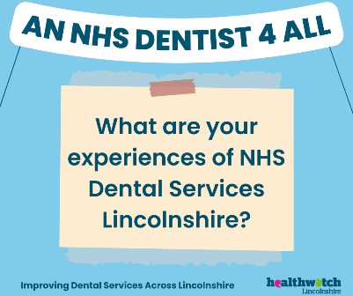  Link to download image: | - What’s your experience of NHS Dental Care in Lincolnshire? Help improve services for everyone by sharing your story: https://www.healthwatchlincolnshire.co.uk/sign-nhs-dentist-4-all-improving-dental-services-across-lincolnshire  #AnNHSDentist4All #LINCOLNSHIRE  - Struggling to access NHS Dental Care in Lincolnshire? You are not alone. Share your experience today: https://www.healthwatchlincolnshire.co.uk/sign-nhs-dentist-4-all-improving-dental-services-across-lincolnshire  #AnNHSDentist4All #LINCOLNSHIRE  - Have you received some great NHS Dental Care? We want to know what makes care great. Share your thoughts today: https://www.healthwatchlincolnshire.co.uk/sign-nhs-dentist-4-all-improving-dental-services-across-lincolnshire  #AnNHSDentist4All #LINCOLNSHIRE
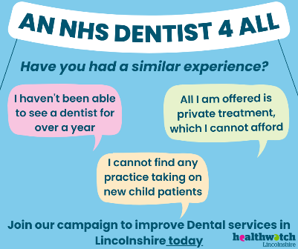  Link to download image: | - Does this sound/feel familiar? Maybe you’ve had a similar experience? Share your story today to make change happen: https://www.healthwatchlincolnshire.co.uk/sign-nhs-dentist-4-all-improving-dental-services-across-lincolnshire  #AnNHSDentist4All #LINCOLNSHIRE  - Have you had a similar experience? Help improve dental services in Lincolnshire by sharing your experience today:  https://www.healthwatchlincolnshire.co.uk/sign-nhs-dentist-4-all-improving-dental-services-across-lincolnshire  #AnNHSDentist4All #LINCOLNSHIRE
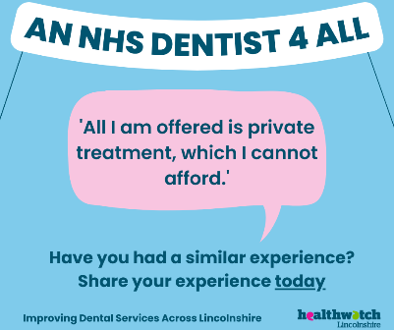  Link to download image: | - Have you only been offered private dental treatment? Help us change this by sharing your experience today: https://www.healthwatchlincolnshire.co.uk/sign-nhs-dentist-4-all-improving-dental-services-across-lincolnshire  #AnNHSDentist4All #LINCOLNSHIRE  - Worried about the cost of dental treatment? You are not alone. Share your experience today:  https://www.healthwatchlincolnshire.co.uk/sign-nhs-dentist-4-all-improving-dental-services-across-lincolnshire  #AnNHSDentist4All #LINCOLNSHIRE  - Private dental treatment for many is too expensive, yet this is all they are offered. Have you had a similar experience whilst seeking dental treatment in Lincolnshire? Share your story today:  https://www.healthwatchlincolnshire.co.uk/sign-nhs-dentist-4-all-improving-dental-services-across-lincolnshire  #AnNHSDentist4All #LINCOLNSHIRE
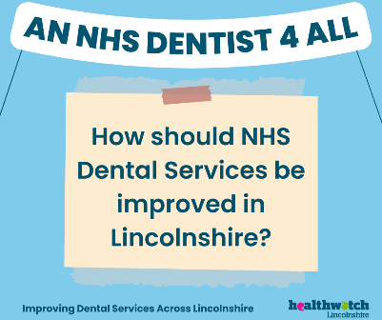  Link to download: | - Have your say – How should dental services be improved in Lincolnshire? Share your thoughts today and help shape service:  https://www.healthwatchlincolnshire.co.uk/sign-nhs-dentist-4-all-improving-dental-services-across-lincolnshire  #AnNHSDentist4All #LINCOLNSHIRE  - Your views matter. How can dental services in Lincolnshire be improved? Help make change happen by sharing your views today: https://www.healthwatchlincolnshire.co.uk/sign-nhs-dentist-4-all-improving-dental-services-across-lincolnshire  #AnNHSDentist4All #LINCOLNSHIRE

Instagram
The images below are the same as the above but have been sized/scaled specifically for Instagram.
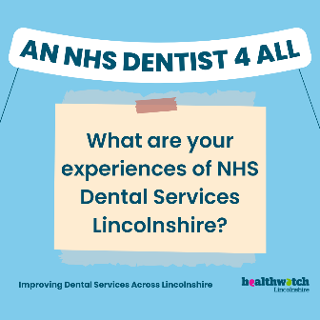 | 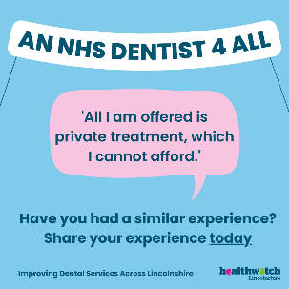 | 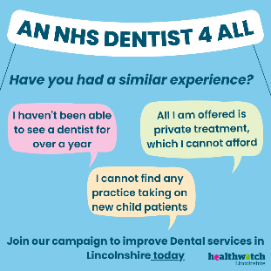
Link to download: | Link to download: | Link to download:

- Now more than ever, our evidence shows that people in Lincolnshire are struggling to access NHS Dental Care. We want to change this. If you or someone you know has struggled to get NHS Dental Care, please share your experience: https://www.healthwatchlincolnshire.co.uk/sign-nhs-dentist-4-all-improving-dental-services-across-lincolnshire

By doing so you’ll be supporting the campaign ‘An NHS Dentist 4 All – Improving Dental Services in Lincolnshire’.
#AnNHSDentist4All #LINCOLNSHIRE
- Access to NHS Dental Care for many in Lincolnshire is a real worry. People tell us that they are unable to find practices taking on new child patients or that all they are offered is private treatment which they cannot afford. We want to change this, but we need your help. Please take two minutes to share your experience via the link below:
https://www.healthwatchlincolnshire.co.uk/sign-nhs-dentist-4-all-improving-dental-services-across-lincolnshire

By doing so you’ll be supporting the campaign ‘An NHS Dentist 4 All – Improving Dental Services in Lincolnshire’.
#AnNHSDentist4All #LINCOLNSHIRE

LinkedIn
Support our campaign to improve Dental Services across Lincolnshire - ‘An NHS Dentist 4 All’
One concern we have repeatedly heard from the public is how hard it is to get NHS Dental Care in Lincolnshire. Whether it is for a preventative check-up, an appointment for a child or urgent treatment, people are unable to find NHS treatment. This is despite often having rung over 10 different practices, which are miles away from their home.
Frequently the only option they are given is to pay for private care, which is simply not feasible for the majority. As a result, people are left in unbearable pain, their dental issues deteriorate further, often resulting in the need for additional treatment, both of which have a detrimental impact on mental health.
We have been hearing such concerns since 2015 and since then we have been raising our concerns around the decline in NHS Dental Services in Lincolnshire. During this time, we have consistently worked closely to raise our concerns with NHS England Midlands Dental Commissioning Team, media, Healthwatch England, as well as with local and regional dental networks.
Whilst we all recognise many of the problems with dental services in Lincolnshire, such as commissioning, workforce and our counties geography. What we see is little or no improvements being actioned.
So, we have started the campaign: ‘An NHS Dentist 4 All – improving Dental Services in Lincolnshire’. Through this campaign we want to bring the issue to the top of the regional and national agenda, but we need your help.
Please support our campaign by encouraging people to come forward and share their experiences, their feedback is vital in improving Dental Services in Lincolnshire.
Experiences can be shared via this link: https://www.healthwatchlincolnshire.co.uk/sign-nhs-dentist-4-all-improving-dental-services-across-lincolnshire
Thank you for your support – together we can improve services for the people of Lincolnshire.
#AnNHSDentist4All #LINCOLNSHIRE

Messages focused on joining and getting involved in the campaign
Twitter and Facebook
Image | Suggested Text
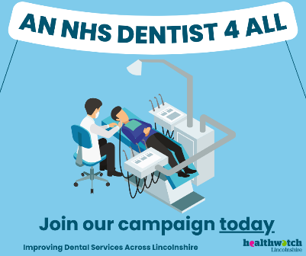  Link to download: | - Now more than ever, people in Lincolnshire are struggling to access NHS Dental Care. Help us raise awareness of this locally and nationally. Join the campaign today:  https://www.healthwatchlincolnshire.co.uk/nhs-dentist-4-all-improving-dental-services-across-lincolnshire #AnNHSDentist4All #LINCOLNSHIRE  - Accessing NHS Dental Services in Lincolnshire can be challenging. We want to change this, but we need your help! Join the campaign today:  https://www.healthwatchlincolnshire.co.uk/nhs-dentist-4-all-improving-dental-services-across-lincolnshire #AnNHSDentist4All #LINCOLNSHIRE
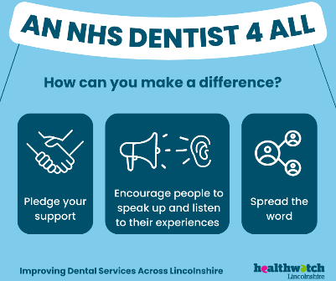  Link to download: | Get involved/make a difference – (three images to pick from)  - Now more than ever, people in Lincolnshire are struggling to access NHS Dental Care. We want to change this. Get involved today:  https://www.healthwatchlincolnshire.co.uk/nhs-dentist-4-all-improving-dental-services-across-lincolnshire #AnNHSDentist4All #LINCOLNSHIRE  - Spread the word. Encourage people to speak up. Those are just two ways to get involved with ‘An NHS Dentist 4 All – improving Dental Services in Lincolnshire’. Find out more today: https://www.healthwatchlincolnshire.co.uk/nhs-dentist-4-all-improving-dental-services-across-lincolnshire #AnNHSDentist4All #LINCOLNSHIRE  - Are you or someone you know struggling to find NHS Dental Care in Lincolnshire? You are not alone. Share your experience today to help bring the issue to the top of the local and national agenda. For more information visit: https://www.healthwatchlincolnshire.co.uk/nhs-dentist-4-all-improving-dental-services-across-lincolnshire #AnNHSDentist4All #LINCOLNSHIRE
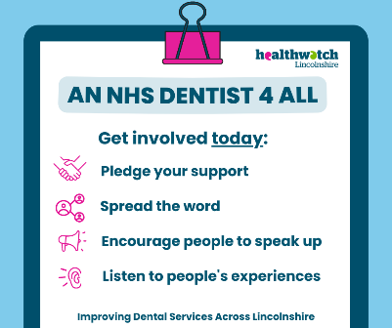
Link to download:
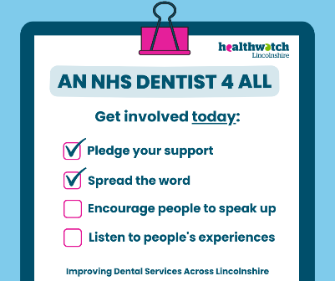
Link to download:
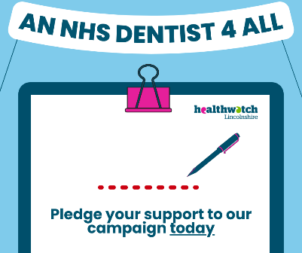  Link to download: | Pledge your support – (three images to pick from)  - Do you want to help improve Dental Services in Lincolnshire? Pledge your support to our campaign ‘An NHS Dentist 4 All – improving NHS Dental Services in Lincolnshire’: https://www.healthwatchlincolnshire.co.uk/nhs-dentist-4-all-improving-dental-services-across-lincolnshire #AnNHSDentist4All #LINCOLNSHIRE  - Worried about the lack of NHS Dental Services in Lincolnshire? You are not alone. Pledge your support and get involved in the campaign ‘An NHS Dentist 4 All – improving Dental Services in Lincolnshire’ today: https://www.healthwatchlincolnshire.co.uk/nhs-dentist-4-all-improving-dental-services-across-lincolnshire #AnNHSDentist4All #LINCOLNSHIRE  - Pledging your support is just one way to get involved in the campaign to improve Dental Services in Lincolnshire. Find out the other ways you can get involved today:  https://www.healthwatchlincolnshire.co.uk/nhs-dentist-4-all-improving-dental-services-across-lincolnshire #AnNHSDentist4All #LINCOLNSHIRE
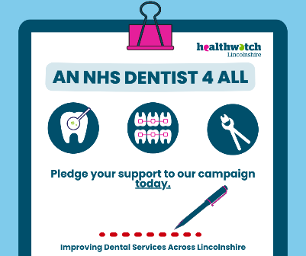
Link to download:
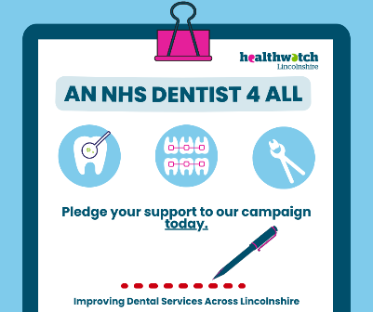
Link to download:

Instagram
The images below are the same as the above but have been sized/scaled specifically for Instagram.
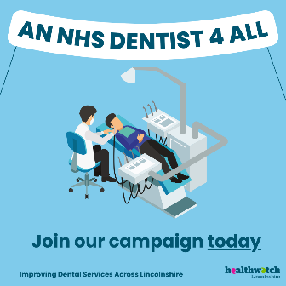 | 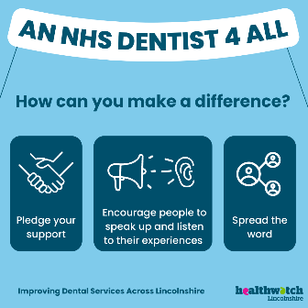 | 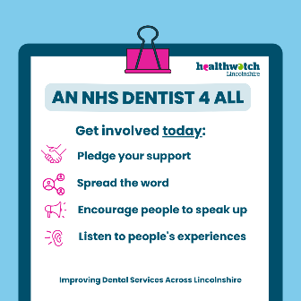 | 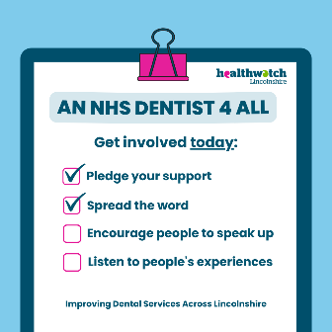
Link to download: | Link to download: | Link to download: | Link to download:
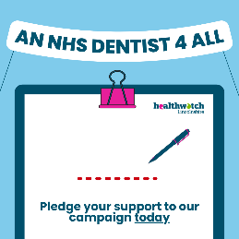 | 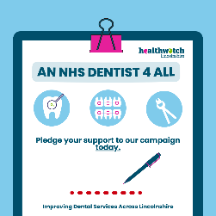 | 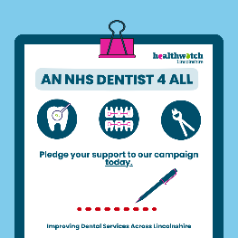

- Your support is vital in improving NHS Dental Services in Lincolnshire. Pledging your support and encouraging people to speak up are just two ways to get involved in the campaign ‘An NHS Dentist 4 All’. Find out more about the campaign and how to get involved today: https://www.healthwatchlincolnshire.co.uk/nhs-dentist-4-all-improving-dental-services-across-lincolnshire #AnNHSDentist4All #LINCOLNSHIRE

- It can be a real struggle to access NHS Dental Care in Lincolnshire. We want to change this and so have started the campaign: ‘An NHS Dentist 4 All – improving Dental Services in Lincolnshire’. To get involved you can: pledge your support, spread the word and encourage people to share their experiences. By working together, we can help improve dental services for people in Lincolnshire. Find out more today: https://www.healthwatchlincolnshire.co.uk/nhs-dentist-4-all-improving-dental-services-across-lincolnshire #AnNHSDentist4All #LINCOLNSHIRE

LinkedIn
Support our campaign to improve Dental Services across Lincolnshire - ‘An NHS Dentist 4 All’
Access to NHS Dental Care in Lincolnshire for many is a real worry. Our evidence shows that it is a problem that is only getting worse but is already having a negative impact on oral and mental health. To raise the profile of the issue, both locally and nationally, we have started the campaign: ‘An NHS Dentist 4 All – improving Dental Services in Lincolnshire’. Through this campaign we want to bring the issue to the top of the regional and national agenda, but we need your help.
What can you do to support our campaign?
We need you to:
- Pledge your support
- Spread the word to colleagues, partners, constituents, and other interested parties
- Download and share campaign content via social media
- Encourage people to share their experiences and have their say through Healthwatch Lincolnshire
To find out more, please visit:
https://www.healthwatchlincolnshire.co.uk/nhs-dentist-4-all-improving-dental-services-across-lincolnshire
#AnNHSDentist4All #LINCOLNSHIRE

