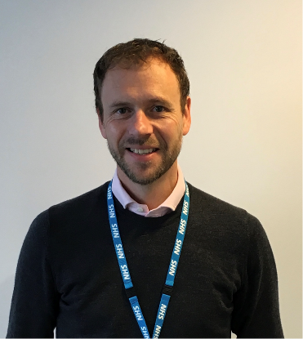
Dr Chris Barker – GPwSI in Pain Medicine
Chris Barker works in Pain Medicine as the Clinical Lead of a multidisciplinary community-based pain & chronic fatigue service for Lancashire & South Cumbria NHS Foundation Trust.
Graduating from University College Hospital, London, in 1994, he spent the first few years of his medical life in general medicine, neurology and anaesthesia. Chris became interested in chronic pain during his initial training in anaesthesia and has continued to develop this over the last twenty years. In 2006 he completed Royal College of Anaesthetists Advanced Training in Pain Medicine at the Walton Centre for Neurology & Neurosurgery as a GP.
Chris has been involved in service design, bids & implementation, and delivery of community pain services both in the northwest and nationally. In addition to working as a GPwSI, he has held posts as a clinical assistant, associate specialist and locum consultant in pain medicine in secondary and tertiary settings.
He now leads a large community based multidisciplinary pain & CFS team providing diagnostic & complex treatment for a population for approximately 500,000. He is actively involved in pain research, national guideline development, and European standards in pain. He advises nationally on the design and delivery of community pain services, represents the RCGP for Pain, is co-opted to council for British Pain Society, and is a member of the NICE Persistent Pain Guideline Committee.
Outside of Pain he enjoys running, cycling, playing drums or guitar and annoying his teenage children
Pete Moore, Pain Patient
Pete’s story is very typical of that of a pain patient. He was, like many pain patients looking for that magic bullet to take away his pain. Managing pain was like playing a game of snakes and ladders – a game of luck. Most days melted into the next and he became a very poor pain self-manager. He did not exercise or generally look after his body and when something went wrong with it, he expected the doctor to fix him.

My Turning Point!
In July 1996 Pete attended the INPUT Pain Management Programme (PMP) London. It was described to him as a programme that could help me to increase his confidence and
mobility and provide him with life-long skills to self-manage his pain.

Pain Toolkit www.paintoolkit.org
Pete authored the Pain Toolkit a simple patient booklet, which was supported by the
Department of Health and now used extensively in the UK and overseas. 950,000 copies
are in circulation in the UK. It’s been translated into 18 languages and adapted for America,
Australia, Canada, Ireland and New Zealand.
Memberships
British Pain Society (honorary member) • The International Association for the Study of Pain (IASP)

